Outings and Events, March 2006
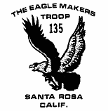
3/17-19 Pt. Reyes backpack
3/25* Sugarloaf hike
4/1* Scout Camp fee due
4/8* Angel Island bike ride
4/28-30* Camporee
5/??- ?? Yolla Bolly backpack
5/?? CPR training
6/16-18 Sailing at Lake Mendocino
7/9-15 Scout Camp at Navarro
7/28-8/6 Yosemite backpack
9/16-18 Yuba River / Gold Country

* new or changed date

February Outdoors: The main outing for the month of Februrary was planned for Loon Lake. However, the troop didn’t go to Loon Lake. We forget where they went but it was somewhere other than Loon Lake. Hold on, this just in... Mr. Ziesche says they went to Boreal. He thinks it was on the north side, but he’s not sure. Mr. Cumming says it was Castle Peak Meadow and Mr. Lake backs him up. Apparently this is at Boreal. There was lots of snow, but it was sunny, so no one got really cold. Mr. Ormond cooked cow and garden stew and all who ate it claimed it was quite good. Reportedly it stewed for 3 hours. Too bad Jarrod didn’t get to eat that instead of Spam. It is said that he ate Spam but only “on a temporary basis.” Cyrus and Ryder both liked the hike in because it was short. Andrew claims that Spencer ran into a tree while "piloting" a toboggan and hit his head. Loren enjoyed the sunny weather because it was “cold and warm at the same time.” We’re guessing he meant the snow was cold and the sun was warm. Mr. Ormond, he of the stew, chose the campsite and Mr. Lake declared that the weather was “tropical.” Mr. Owen learned some things he wished to pass on. 1) Make sure your fuel canister matches your stove before you leave. 2) Putting a Nalgene bottle filled with heated water into your sleeping bag will keep you warm at night but can also result in second degree burns to your legs if you aren’t careful. #1 was an observation, #2 was borne of personal experience. Rumor has it that Mr. Holtz skied to camp and dragged his pack on a sled, but this could not be confirmed at press time.

What is the Big Deal with Toboggans? We at the NewsletterTM staff have never figured out the reason for the popularity of the toboggan. There is no way to steer it, ask Spencer. It gives the impression that if one leans to one side or the other there is some form of directional control, but this is only an illusion. One might as well get in a barrel and go over a waterfall, it amounts to the same thing, except in the case of the toboggan the water is frozen. And let’s not forget that with the toboggan there is the opportunity to run into large stationary objects like boulders and trees, which just happen to be in plentiful supply wherever the terrain would suggest making a good run. Unlike an inner tube or one of those discs, which skim along on top of the snow, a toboggan literally hurtles itself downhill and it takes you with it. It is momentum incarnate. At least when you get on an inner tube or disc you are fully aware that there is no control. The toboggan is evil, plain and simple. Roughly translated, toboggan means “crazy random maiming board” in the Washoe Indian language. Or at least it should...

February Outdoors II, The Sequel: Several intrepid individuals took a trip through Annadel State Park on Feb 18, led by Mr. Weil and Mr. Ryall. James, Andrew, Loren, and Spencer C. covered 10.5 miles in one day. Thundershowers were predicted but the weather held and no one really got wet at all. There were very few people in the park, though, and the hike was pretty quiet. Spencer spied some turkeys from afar off, and there were some rabbits, deer, and a few hawks. Three of the Scouts wrote a short description of the hike and got two requirements signed off for the Hiking merit badge. The next 10-mile hike is scheduled for March 25th. Hey, that was last weekend.

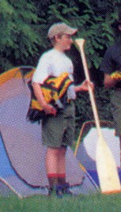
January Mystery Scout: Our January mystery contest photo was submitted by Mr. Cumming and was inserted into the NewsletterTM in good faith since we at the NewsletterTM staff did not know his identity. However, Mr. Cumming does not know who the Scout is, either, and could only tell us that he came from the back cover of the Scout Handbook. That Mr. Cumming, he’s such a kidder. Go get your handbook and check it out. In the original image there are three figures standing in a clearing, a Scout on the right and the left with a leader in the middle. It looks like the leader is acting as a referee and the Scouts are about to go three rounds no-holds-barred beating each other with boat oars. After studying the image extensively your NewsletterTM staff believes the leader is saying, “Gentlemen, let’s get ready to RUMBLE.” What other reason is there for two Scouts to be facing each other in a forest clearing armed with boat oars?

February Mystery Scout: Our Mystery Scout for last month (February) is related to the youth pictured at a Boy 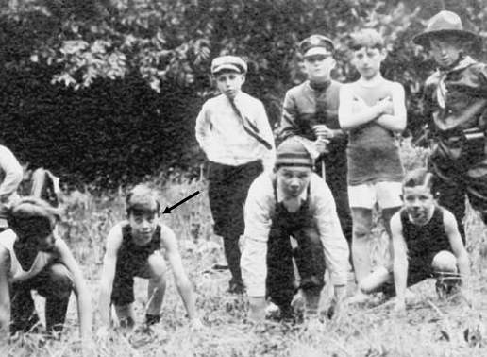Scout foot race in 1917. The boy in the photo is the great-grandfather of James Ryall, whose father and grandfather were also Boy Scouts. That makes him a fourth generation Scout. The young man pictured is Alan Ryall.


Mystery Scout of March: Our Mystery Scout for the month of March is too cool for school as you can see from the photo on the right. Can you guess who it is?

New SPL. Justin Lake was recently elected to the office of Senior Patrol Leader in a very close vote. He led his first backpacking trip in Point Reyes this month and found that it is one thing to go on a trip and quite another to be responsible for everything. He adapted well and came through with flying colors. Congratulations, Justin.

News Flash: The new patrols have been named. James and Robbie decided that there would be no more lame-o names and threatened to assign names if the Scouts couldn’t do better. One patrol liked its assigned name (Thunderclaw: The Patrol of Doom) better than anything it could come up with on its own. A little research turned up the following information about Thunderclaw:

Killed by Lightspeed Solarzord. Thunderclaw was later summoned by the Shadow World's Gatekeeper in a zombie-like state to battle the Rangers but the Gatekeeper lost control when his staff was broken. Thunderclaw was defeated and absorbed by Olympius in order for him to become stronger and escape the Shadow World.

Okay...The other patrol came up with the name Retarded Tigers, but this was rejected as being lame. The assigned name, Mogfang: The Patrol of Insanity, is obviously a superior and unlame patrol name. Hello. Perhaps someone should be monitoring the monitors.

Patrol Flags: In the spirit of the new patrol naming convention, the NewsletterTM staff has taken great pains to design and propose the following patrol flags:
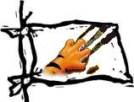
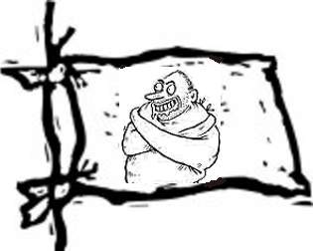
Scout Camp 2006: Yes, indeed, it’s at Navarro, it’s July 9-15 and the cost will be $245. Or some other amount.

Scout Camp Update: Whether the cost is $245 or not, a $100 non-refundable deposit is due by April 1st. Lou especially wants that you should note the non-refundable part. Lou “recommends” that you not neglect to make your payment. Not to panic you, but Lou was recently seen in the Official Boy Scout store purchasing a set of BSA brass knuckles. It is likely that there is some explanation for this other than the obvious one, so not to worry. .

Scout History the Ormond Way: Question: When was a president a president and a president a vice president? Answer: 1929 when Herbert Hoover was honorary president of the BSA and Calvin Coolidge was vice-president..

James’ Eagle Project: James Ryall is still closing in on achieving the rank of Eagle. He has one requirement left on his Emergency Prep merit badge, 2 more 10-mile hikes, and most of the Family Life merit badge to complete. His Eagle project will be coming up soon because he turns 18 on June 3rd. It would help if he knew what he was going to do and when he was going to do it, both of which are unknown at this time. Scouts are encouraged to ask James what days they should set aside for working on his Eagle Project. The Troop Committee recommends that each Scout do this every week until they get an answer.

Intellectual Property: Well so far in our search for world domination we have trademarked the word NewsletterTM and developed several promising slogans, like “Join Us & We’ll Give You a Knife & Let You Light Fires”, so you can rest assured that Troop 135 will not be left behind in the new economy. Our next move is outsourcing. It occurs to the NewsletterTM staff that hiking and backpacking are hard work and there is no real money in it. As everyone now knows it is ideas that have value, anybody can make and do things. The key is to know what to do and make. That’s where the expertise of Troop 135 really gets some traction. From now on, just like long-term-thinking corporate America, Troop 135 will come up with the ideas and then outsource the actual work to other less developed countries like India, China, and Mexico. Our first ingenious plan is for a 35-mile backpack in Yolla Bolly. We are thinking that China would be a good place to outsouce this trip, since their labor rate is really low and the country is so huge there must be a place exactly like Yolla Bolly somewhere over there. That would mean they wouldn’t have to travel to the US, which saves us lots of money. That’s how you come out ahead, by saving lots of money. We will have to supply the video cameras, though, so the trip can be recorded and we can have the full benefit of the backpacking experience. Everyone knows watching a video of somebody else is as good as doing it yourself, that’s why Reality TV is so popular. It isn’t yet clear how outsourcing the trips will build the character of the troop members, but that is just another idea we need to develop and ideas are what we do best. With all the time we will save by not going on trips we are sure to discover the idea that is key to answering that question. As always, your NewsletterTM staff will keep you informed as things transpire.

NewsletterTM:

- Insider info by J Ryall
- Email address for complaints, corrections, constructive criticism, comments: rjr@neteze.com

